Medicinal herbal plant lore walk – A few key take home points Naomi Smith (Bachelor of Health Science – Naturopathy)
 | Historical roots | Medicinal uses | Parts used | Garden growing | Kitchen creations | Cautions
Borage  Borago officinalis  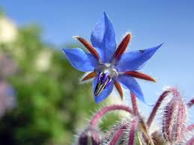 | Ancient associations with courage, gladness and forgetfulness. Thought to lift spirits and promote good cheer. Was often steeped in wine to induce relaxation and sedation, reducing everyday worries and cares. | Soothing as a respiratory herb, may also be used as a tonic to assist convalescence following colds or flu. Helps to restore and improve adrenal function. Induces diuresis, and has stool softening actions. | Dried leaves are used medicinally, and seeds, which hold high amounts of GLA can also be used. | Grows up to 60cm tall and 50cm across. Is self-seeding. Best sown spring following the final frost through early summer, directly inserted 1cm into soil. Makes ideal companion for strawberries. Attracts bees. | Try as a tea. The young leaves and flowers taste like sweet cucumbers. Infuse them in oil, pickle, add to soups, salads, or fry fritters. The fresh plant juice may be used as a tonifying and cleansing agent for the skin. | Avoid use during pregnancy. Increased miscarriage risk.  Caution for those on blood thinning medications due to theoretical increased bleeding risk.
Calendula  Calendula officinalis  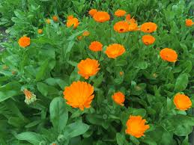 | Associated with the sun. Ancient Egyptians ascribed it rejuvenating qualities. Romans reportedly applied it directly to many-a skin conditions and wounds. Used to colour foods, and provide comfort to the heart. | Topically for skin conditions including rashes, ulcers, dry skin, wounds and scars.  Internally fo stomach upsets (i.e. cramps), and other internal spasmodic conditions, fever and enlarged lymph nodes. | Fresh or dried flower heads. Historically  whole plant was used including seeds & roots | Seeds best sown springtime directly into moist well-draining soils. Minimal care. Germinates in 10-14 days. Attracts predator insects. Leaves and stems branch out and up to heights of over 40cm. Easy to grow in pots. | Tea infusion or decoction.  Add to a bath or a stocking and use as a compress. Create oil infusion, and apply to skin. Include creatively in a range of meals from salads to stews, or as a decorative garnish. | Avoid with known Daisy family allergies. Use only with professional supervision during pregnancy or lactation
Chamomile  Matricaria chamomilla  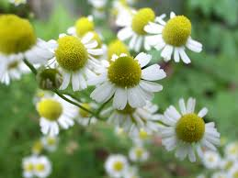 | Reported to have the greatest number of uses in folk plant medicine, it has been applied to a myriad of ailments since antiquity in Egypt, Rome & Greece. Egyptians would worship it to the point that they dedicated it to the sun. | Mildly sedating, and used effectively in a number of digestive ailments, it can calm an anxious stomach and restless mind. Topically too, it may assist conditions from infections to allergies, ulcers, and teething problems in tots. | Flowering heads | A Roman annual or hardy English perennial, seeding in sunny spots in spring, needs light to germinates taking 7 to 14 days. Prefers light soil and some shelter in the hotter months. A beneficial companion plant to many. | Other than tea, the flowers have been used in many recipes such in icecream, and blended in sauces for raw fish and scallops. It may also be used in creams, soap etc. or as a rinse for light hair producing golden shine. | Avoid with known allergies to the Daisy family. Also, chamomile tea can reduce the absorption of iron, so avoid in iron deficiency anaemia.
Dandelion  Taraxacum officinale  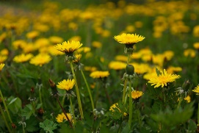 | From Greek word ‘taraxos’, meaning a disorder, the common name is from French ‘dents-de-lion’, meaning lion’s teeth. Old herbals drew the leaves to looks like the jagged teeth & jaws of lion’s. | An extremely nutritious plant. Leaves are rich in vitamins including A, E, K, C, B’s and many minerals including iron. Notable benefits to the liver and whole digestive system; the kidneys and the blood. | Root, leaves and flowering heads | Produces seeds without pollination and therefore the offspring are genetically identical to the parent. Leaves harvested late spring are less bitter Also, grow in the shade for less bitterness. | Best to dig roots in Autumn. They can be baked to make a coffee substitute, or eaten as a root vegetable; made into a decoction. Add the young leaves to salads, stews, soups, or dry for tea. | Avoid use in known Daisy family allergies, and in cases where there is an occlusion of the biliary or intestinal tracts, or in gallbladder disease.
Lavender  Lavendula angustifolia  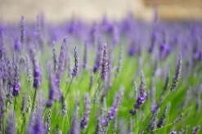 | Used traditionally for depressive states and headaches, lavender was also used as a stimulant for children. Has ancient associations with passion, romance and seduction. | Best known for effects on the nervous system with anti-depressant, anti-anxiety and sedative effects, It is also used to calm stomach upsets, as an anti-microbial, & topically for muscle cramps. | Flowers | Prefers full sun, tolerates some shade, liking light, well-drained loamy soil, will attract birds, bees and butterflies. Propagate from the woody stem cuttings, kept in shade many months. | Best harvested when the buds have formed, but the flowers have yet to open, as these are more fragrant and better retain colour. Add the tiny flowers to tea, or use as a calming aromatherapeutic. | May increase anti-depressant and sedative effects. Cases of contact dermatitis reported. Essential oil best avoided during pregnancy & with caution during lactation.
Nasturtium  Tropaeolum majus  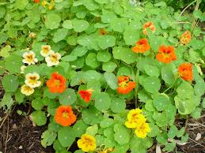 | From Latin roots meaning ”twisted nose” relating to one’s expression upon eating the bittersweet, peppery leaves. Native to Peru and Bolivia, it travelled to Europe in the 1600’s, and was used eaten to prevent scurvy. | Vulnerary, demulcent, wound healing & anti- inflammatory, it contains substances remedy to a variety of local infections. Internally it can help expel mucous in respiratory tract infections including common colds, flu and bronchitis. | Leaves, seeds, flowers | Fast growing, self-seeding annual, thriving on neglect. Enjoy full sun, cool, damp well-drained soil, being planted under many-a fruit trees, and companionship in general. Flowers picked regularly stimulates growth. | Best fresh, the leaves & flowers can be added to salads, and a wide variety of other dishes, adding a biting peppery flavor, or make a decoction. Externally it can be applied as a poultice or compress to infections. | High oxalic acid content can cause stomach upset. Toxicity affects the kidneys, therefore avoid in kidney disease, and gastrointestinal ulcers. Can produce contact dermatitis.
Nettle  Urtica diocia  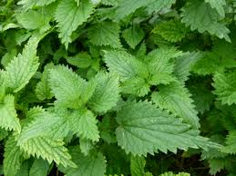 | A pudding made from nettle and other wild green was thought to be among the first dishes prepared in Britain. Used as a vegetable, it was thought to strengthen and support the whole body, and offer a form of blood purging. | A good source of protein, high in many minerals, vitamins and essential fatty acids, nettle offers a blood tonic. Also notably containing histamine it presents a remedy to address a variety of aggravated skin conditions. | Root and aerial parts can be used | Its nutrient richness is especially useful for compost, including compost teas and mulch. It is an annual or perennial depending on location, doing best in moist soils and in more shady spots. | Nettle is a wonderful addition to any tea brew, or to add extra nutrition goodness to soups, stews, or many other dishes. Dry or blanch the leaves in hot to boiling water to rid the stinging nettles. | Best avoided medicinally during pregnancy and lactation. The fresh herb can produce irritation, so avoid if sensitivity & allergic reactions are noted. Maybe wear gloves during harvesting.
Peppermint  Mentha × piperita  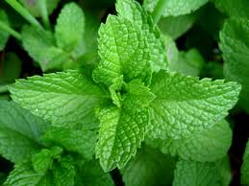 | Named after Mentha, a Greek mythology seductress, it was originally used not only to treat stomach disorders, but as a remedy for everything, including hysteria. Among key applications include nervous complaints, headaches& colic. | Offering mild anesthesia to the stomach wall, it is used for headaches, many digestive complaints, and headaches resulting from digestion. The essential oil menthol is topically cooling, relieving itching irritated skin. | Leaves | A perennial with a square woody stem that can act as a self-inflicted weed, spreading quickly, infiltrating and consuming spaces. Better contained in pots. Flourishes in shady and moist places. | Most commonly prepared as tea, it is also used to garnish various cool drinks. Culinary uses include sauces and to flavour the like of potatoes and peas. Menthol is the raw essential tooth-paste ingredient & creams etc | Medical supervision vital during pregnancy & lactation. Avoid in GORD, severe liver damage, gall bladder conditions & iron deficiency anaemia. Tea reduces iron uptake. Some contact sensitivity.
Rosemary  Rosmarinus officinalis  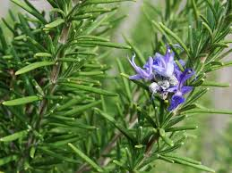 | Used for remembrance since ancient times unsurprisingly it continues use for cognition, clarity & memory. Greek students would place sprigs behind their ears. Folk legend had it that the flowers turned white to blue for Virgin Mary. | May help to manage anxiety & depression, & reduce age-related cognitive decline. Its antioxidants help to protect the brain, and detoxify the liver. The smell reduces stress lowering cortisol. It improves hair quality & growth. | Leaves | A woody perennial loving sun and heat. It is difficult to raise from seeds. Better to propagate or obtain a plant from an organic greenhouse. Likes the occasional water, but not overdone, as it requires little for growth. | It can be infused in oil, added to conditioner, or infused as tea to make a hair treatment. Commonly added to roast vegetables and meat dishes. Have sprigs handy & smell during study and tests to improve focus. | Seek professional advice during pregnancy & lactation. Avoid where known allergy, and oil bathing when large open wounds/lesions, acute infection, hypertension or fever are present.
Sage  Salvia officinalis 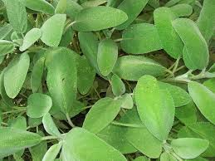 | Latin for 'salvere', meaning “of good health”; to cure, save; & “savior”, it was considered sacred by our ancient ancestors, used ceremoniously, & in a concoction devised to ward off Black Death. | Digestive issues, coughs, colds, inflammation & mouth, tongue & throat infections; low mood, exhaustion, nervous debility, attention deficits; PMS, uterine pain & excessive menstrual bleeding; menopausal hot flushes. | Leaves are the plant part used medicinally | Low maintenance perennial schrublet, attracting insects including butterflies & bees; & repels various garden pests. Harvest leaves all year. Flowers mid-summer to early Autumn. Variable according to climatic region. | Both leaves & flowers are edible. The leaves are typically cooked, though young leaves can be enjoyed raw. Considered a herb best used solo in savory dishes. The flowers make great garnishes (salads, cakes etc). | Concentrated forms i.e. essential oils or alcohol extracts, should be avoided long-term due to thujone content. This is toxic to the liver and kidneys. Avoid during pregnancy and lactation.
For some more in depth herb explorations check out Naomi’s ‘A Herb for Thought’ on permablitz.net

