
TIPS ON HOW TO REPORT FROM A PERMABLITZ

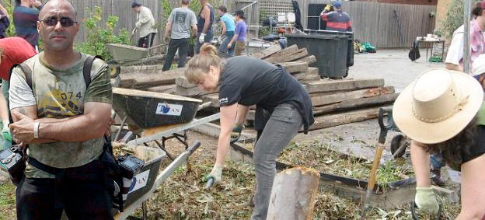
Contents:
Goals 2
Tasks 2
You’ll need: 2
Documenting the day 2
Post-blitz 9

This guide is for people who are taking photos/video/writing a report of a permablitz for the permablitz.net website.

Thanks for agreeing to help document a permablitz! In the past some wonderful achievements and work in the permablitz world have gone undocumented, so you’re helping us to change that.

Goals
We’d like you to record the day's events as they unfold—“before” and “after” shots, portrait snaps, as well as shots of various projects from start to end. If you’re into video, you may wish to document the blitz through film or by doing a timelapse.

Tasks
- Introduce yourself at the blitz (a good time to do this is during the initial gathering circle) and find out if anyone doesn’t want to be photographed
- Take photos/video/write a report/let your creativity run wild!
- Share the photos after the blitz with our Documentation Co-ordinator
- If you can, send the Documentation Co-ordinator a short written report too

You’ll need:
- A digital camera
- Possibly a pen and paper to take names and notes if you're also writing a report

Documenting the day
- Arrive early enough so that you can capture the “before” shots, prior to everything being permablitzed!
- Introduce yourself to the host and lead designer/ facilitator and find out what the main activities will be throughout the day
- Ask the lead facilitator to introduce you or do this yourself during the gathering circle and reiterate that you'll be taking photos throughout the day for the website. That way if people prefer not to have their photo taken they can let you know
- You can still participate in the blitz when you're documenting! Just make sure to visit all of the activities happening throughout the day so that you can show the overall process of the permablitz. Talk to the facilitators so that you have an understanding of what exactly it is that you're photographing—this will help with the reporting side of things
- Don't forget to take photos that capture the overall energy of the day as well - it's good to show folk who haven't been to a permablitz before that it's a lot of fun, not just work! It's great to capture people connecting over lunch, kids getting involved; anything that has helped make the day special.

We love portraits and semi-posed shots!

The best photos are usually not crowd shots, but instead feature one or a few people in the foreground. Ask people to smile and get some semi-posed shots – a minimum of 10 posed shots per permablitz is a good guide. If it’s a small blitz, it’s nice to aim for a shot of everyone. Ideally they’ll be in the foreground, working on something, with action in the background showing the blitz. If you can't see their name-tags, make a note of participants names, and include them with the photos.

Here’s some examples of the kind of photos that work well:

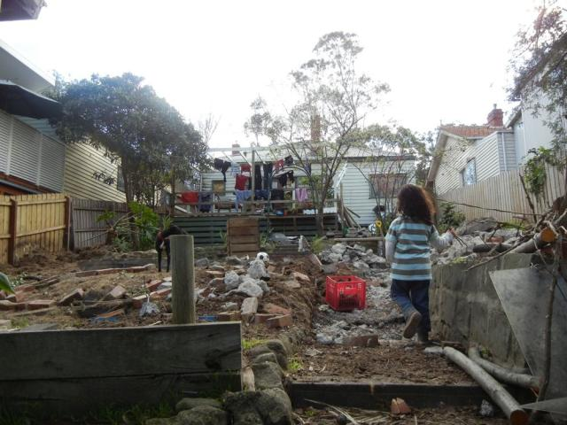
A “before” shot

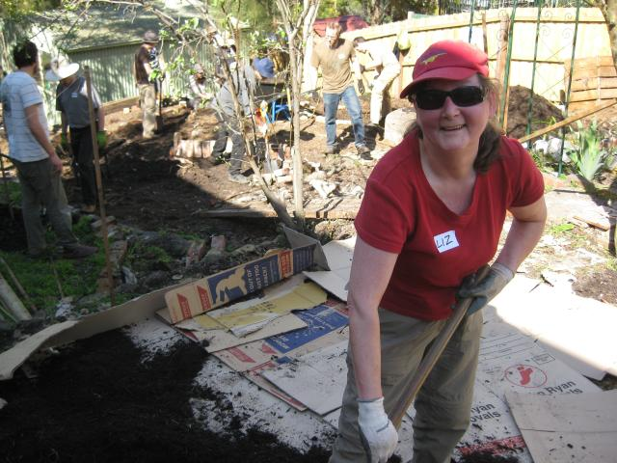
Portraits with action in the background
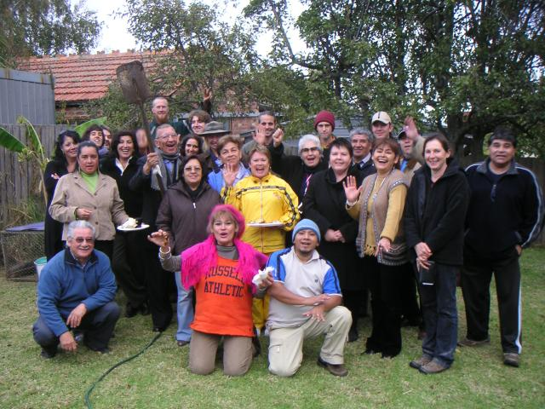
Posed crowd shots
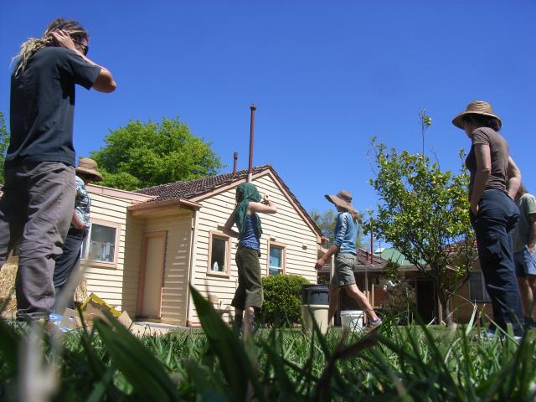
Interesting angles
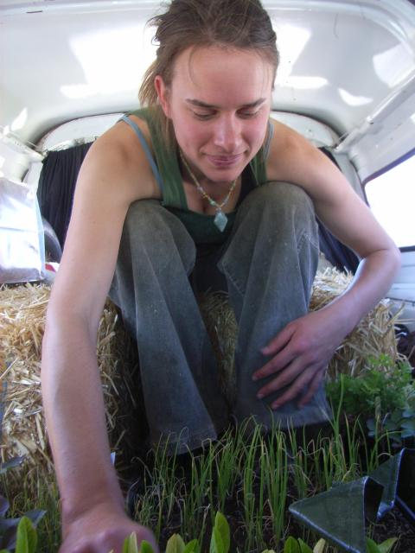
Novel situations

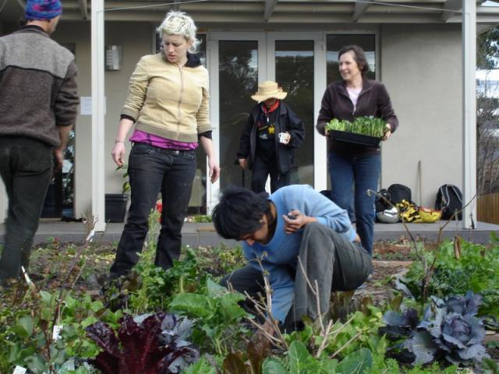
Un-posed action shots

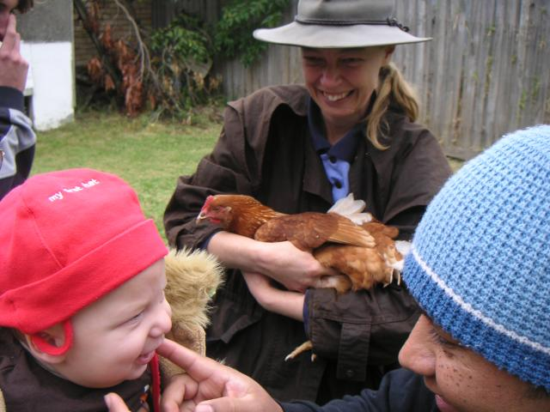
Always work with kids and animals

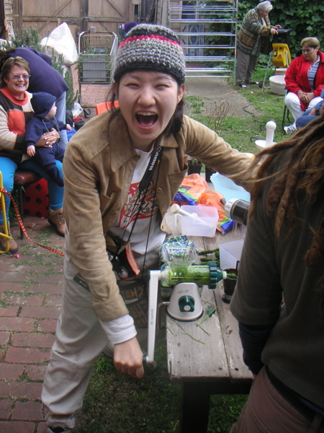
Characters

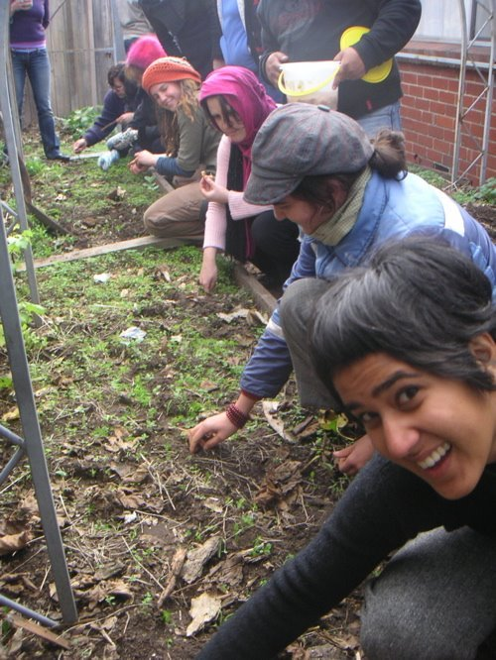
Smiles
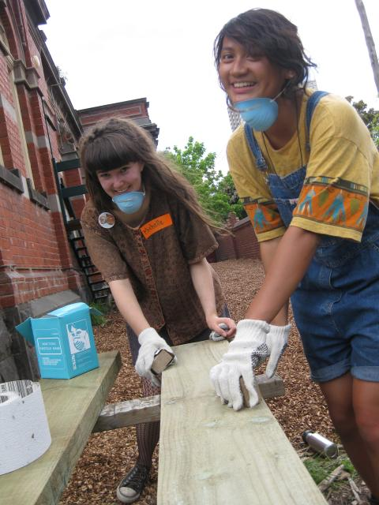
Never too many semi-posed shots – try to get a good shot of everyone
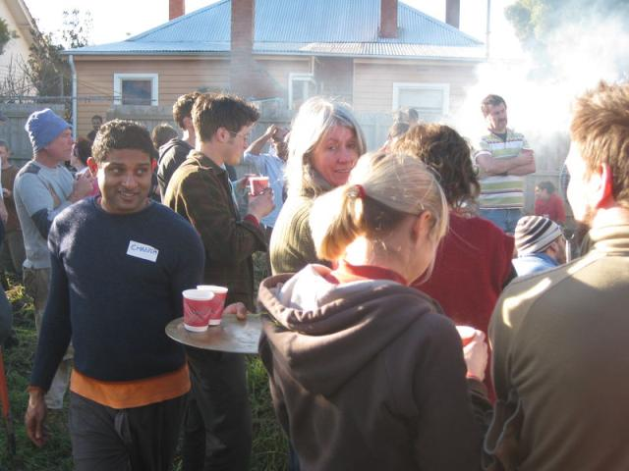
Hospitality
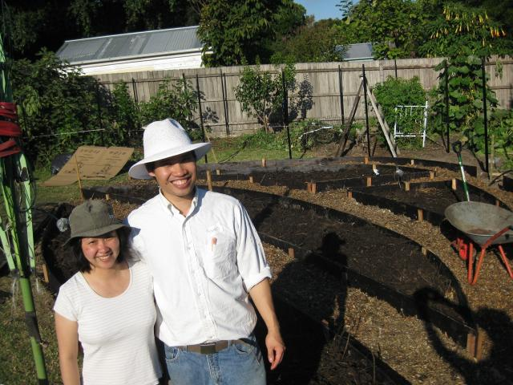
Happy hosts

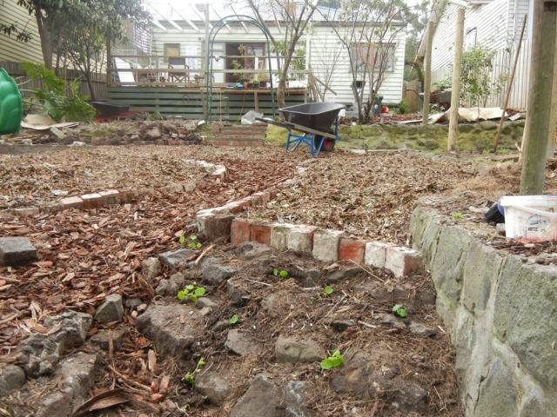
An “after” shot

Post-blitz
After the permablitz we'll need to get the photos up on the website. If there’s someone from the permablitz collective with a laptop at the blitz, we might even be able to get them from you then and there, otherwise the Documentation Co-ordinator will be in touch. If you know how to use the program Dropbox (www.dropbox.com – it’s free and really easy – after installing it you simply save the files to a shared directory), please pop your photos on there, otherwise we can talk you through uploading the photos directlyto the permablitz.net gallery. Let us know how you’d like to be attributed on the website.

For any queries please email us on permablitz@gmail.com.

Thanks so much for your help!

Document Version
Created: 09/09/11 Adam & Angela
Updated: 23/01/12 Adam (added CC license), 10/08/12 Sam, 13/11/12 Adam

This work is licensed under the Creative Commons Attribution-NonCommercial-ShareAlike 3.0 Unported License. To view a copy of this license, visit http://creativecommons.org/licenses/by-nc-sa/3.0/

To get an editable copy of the latest version of this document please email: permablitz@gmail.com. Our guides are written on OpenOffice.org and/or LibreOffice.org, free, open-source office suites! If you'd like an editable copy of this document, you may need to install one of them. It's quite easy, and you can stop paying for Microsoft products.

